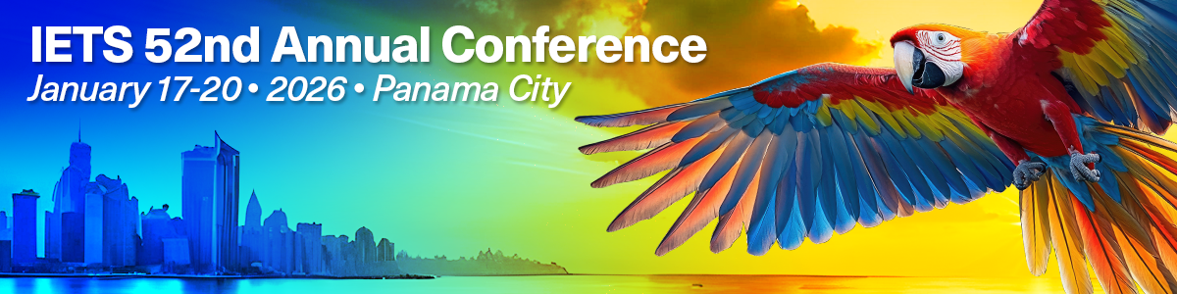
Major Professor/Faculty Supervisor Email Template for IETS 2026 Student Verification

Subject: Request for IETS 2026 Annual Conference Student Membership Verification

Dear major professor’s or faculty supervisor’s name,
I am writing to request your assistance in verifying my student status as part of the International Embryo Technology Society (IETS) 2026 Annual Conference student competition process. As a current undergraduate/graduate/postdoctoral/veterinary student in your department/major in the your degree program at university name, I am interested in applying to this professional organization’s competition name to support my academic and professional development in embryo technology and scientific excellence.
The IETS requires an academic representative to verify my current student status and research novelty. Please help me by forwarding this email to iets@iets.org and confirming my eligibility for the competition name by
- Endorsing that the experimental data presented in my attached abstract is original and was gathered during my degree program,
- Verifying that I was a student in 2025, and
- Approving that the data in my abstract has not been accepted for publication elsewhere, nor will it be presented at any national or international meeting before the IETS 2026 Annual Conference. (If research containing the same data I used in my abstract will be published before the competition in January 2026, my abstract must be withdrawn immediately, and I will lose eligibility to compete at the IETS 2026 Annual Conference.)
The competition name at the IETS 2026 Annual Conference offers substantial cash prizes to the awardees, alongside the prestigious recognition of being an IETS award winner. Finalists will be recognized at the award reception during the program. If I’m invited to present, I’d love to have you attend with me in Panama City from January 17 to 20, 2026.
I appreciate your help! Thank you for supporting my professional development and research ventures.
Sincerely,
your name
your student ID

